Evidence for Implementation and Testing Unit

Joe Stafford

Cohort: E21

I.T. 5 - Demonstrate the use of an array in a program

* An array in a program (@occupants, @songlist are both arrays in the Room class)

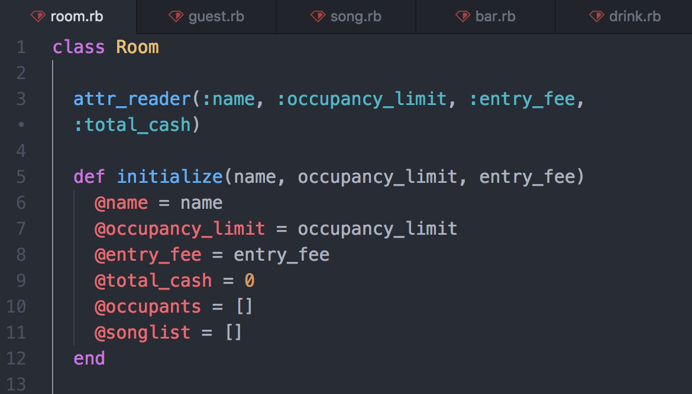

* A function that uses an array (find_guest_by_name method loops through the @occupants array)

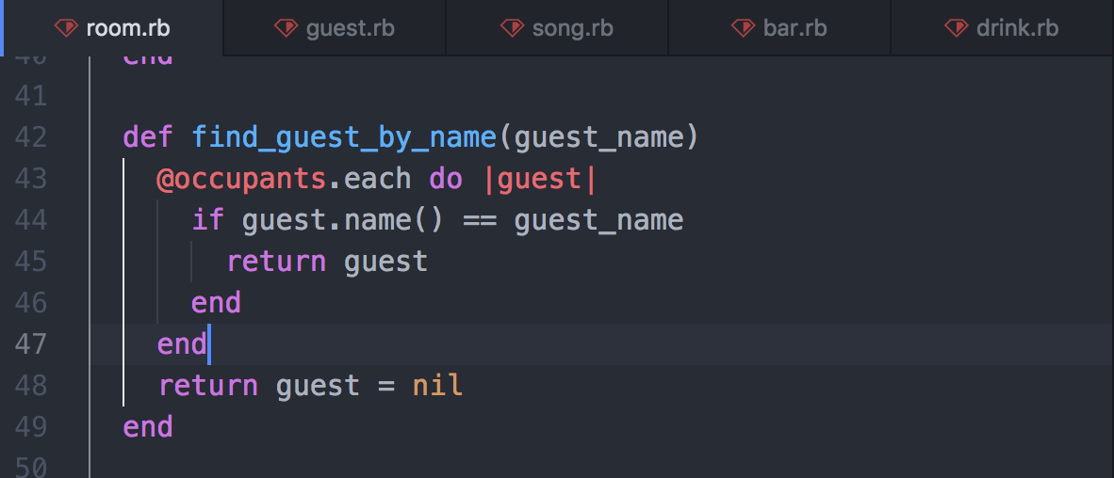

* The result of the function running (Below shows successful tests and the test I used to test the above method)

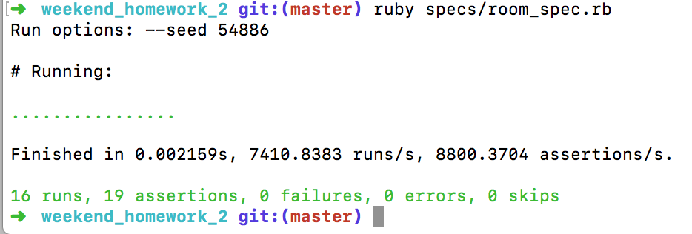

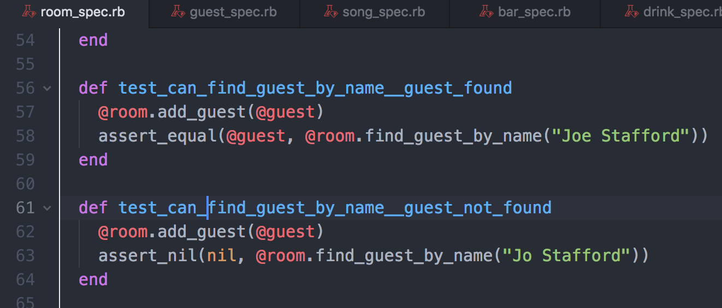

I.T. 6 - Demonstrate the use of a hash in a program

* A hash in a program (a hash of a pet, with several key - value pairs)

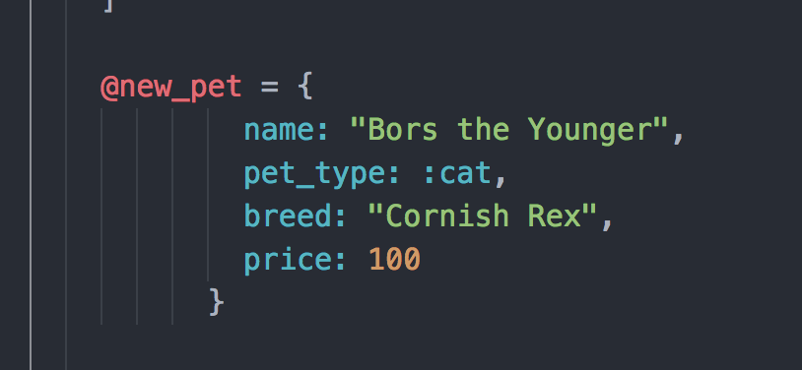

* A function that uses a hash (this method adds the new_pet hash to the customers array

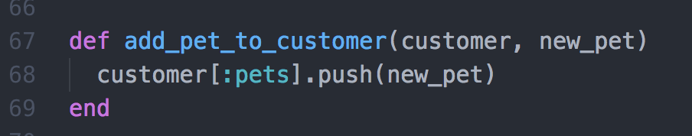

* The result of the function running (Below shows successful tests and the test I used to test the above method)

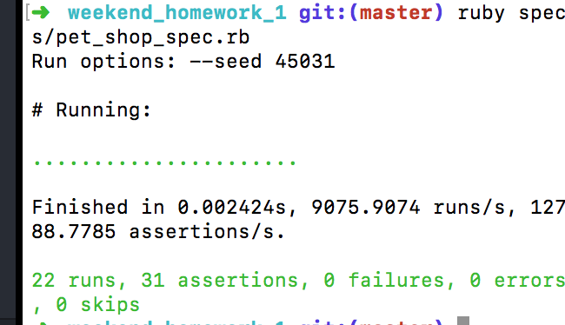

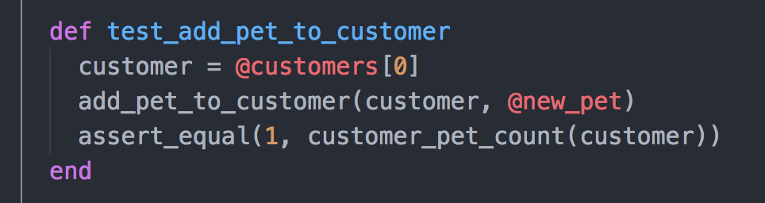

I.T. 3 - Demonstrate searching data in a program

* Function that searches data (The below method utilises an SqlRunner to run the SQL statement ‘SELECT’)

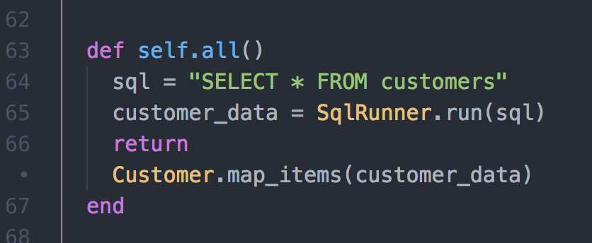

* The result of the functioning program (Below shows the array of hashes returned when calling the function above)

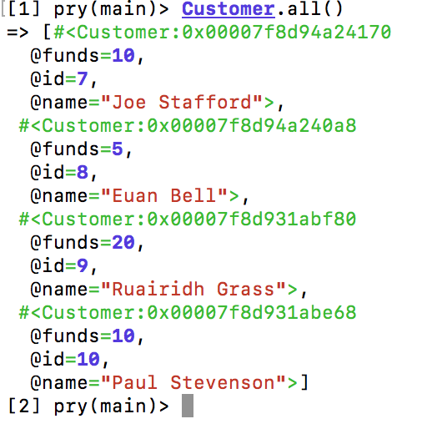

I.T. 4 - Demonstrate sorting data in a program

* Function that sorts data (below function shows sorting data using the id of a customer to select all films that customer is going to see)

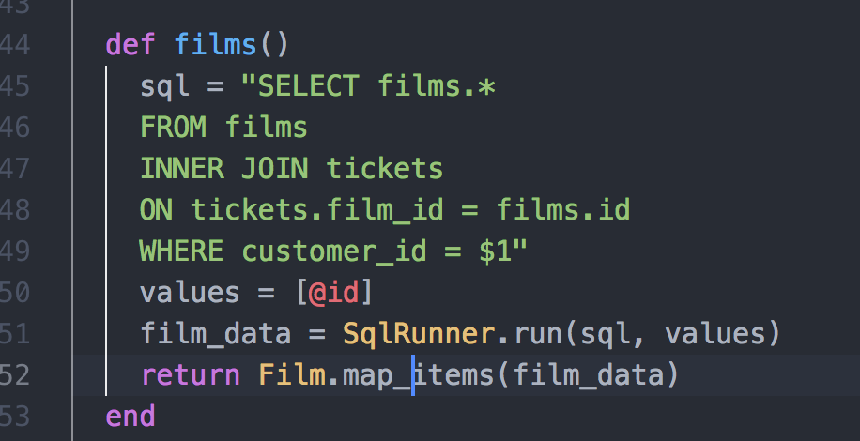

* The result of the function running (this shows an array of hashes showing the films that the object ‘customer1’ is going to see)

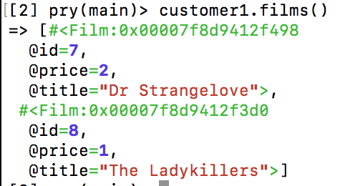

I.T. 7 - Demonstrate​ ​the​ ​use​ ​of​ ​Polymorphism​ ​in​ ​a​ ​program

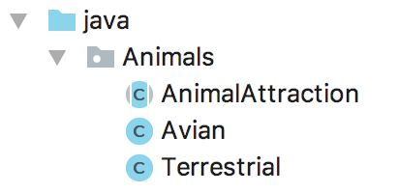

* Above shows an abstract super class ‘Animal Attraction’, and two sub-classes, ‘Avian’ and ‘Terrestial’, which extend the super class.

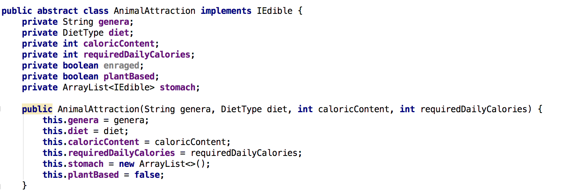

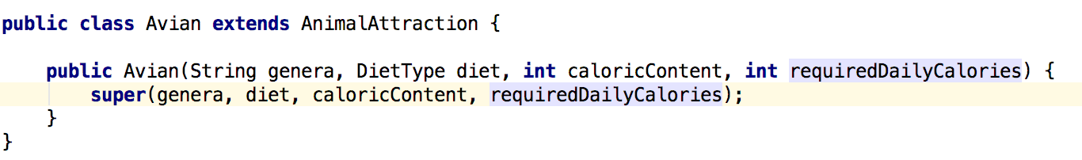

* An object of type Avian is both an ‘Avian’ and an ‘Animal Attraction’.

I.T. 1 Encapsulation in a program

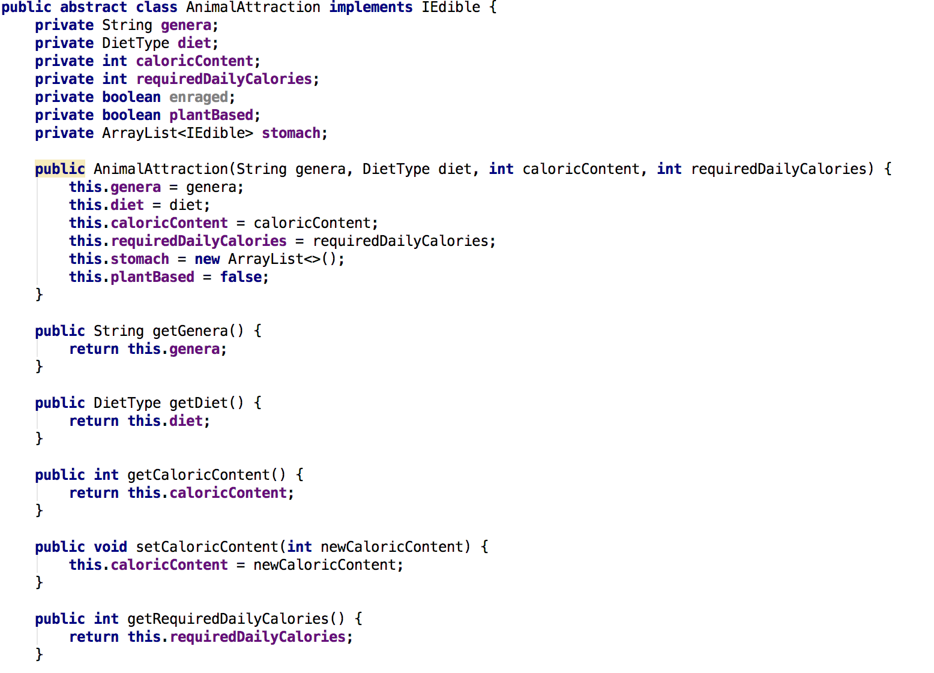

* The above code shows several private variables, and a sample of getter and setter methods used to get/set the private variables

I.T. 2 - Use of inheritance in a program

* Super class



* Class that inherits from above super class



* An object of above class



* A method that uses the information inherited from another class

